

**Theory Assignment Report**

|  |  |  |  |  |  |  |
| --- | --- | --- | --- | --- | --- | --- |
| **Only for course Teacher** | | | | | | |
|  | | **Needs Improvement** | **Developing** | **Sufficient** | **Above Average** | **Total Mark** |
| **Allocate mark & Percentage** | | **25%** | **50%** | **75%** | **100%** | **5** |
| **Clarity** | **1** |  |  |  |  |  |
| **Content Quality** | **2** |  |  |  |  |  |
| **Spelling & Grammar** | **1** |  |  |  |  |  |
| **Organization and Formatting** | **1** |  |  |  |  |  |
| **Total obtained mark** | | | | | |  |
| **Comments** |  | | | | | |

**Semester:** Spring 2023

**Team Name: Team** VORTEX

**Students Details: Meria Mostofa Mim (0242220005341043)**

**Mohammad Nowshad (0242220005341218)**

**Safin Razoan Obid (0242220005341224)**

**Istewak Hassan Tewak (0242220005341228)**

**Batch: 39 Section: E**

**Course Code: SE212 Course Name:**

**Course Teacher Name: Tapushe Rabaya Toma (Senior Lecturer)**

**Submission Date: 1st June, 2023**

**Table of Contents**

**Some Beautiful Moments** 1

**Informer’s Info** 2

**Objectives & Impacts** 3

**Software Elicitation Technique** 4

**SRS Documentation** 5

**Use Case Design** 17

**Use Case Description** 21

View Total Sell 21

Admit Patient 23

Manage Doctor 25

Investigate Test Report 27

**User Profile of ADMIN** 29

**Requirement prioritization (Moscow)** 30

**Traceability Matrix** 32

# 

# **Some Beautiful Moments**

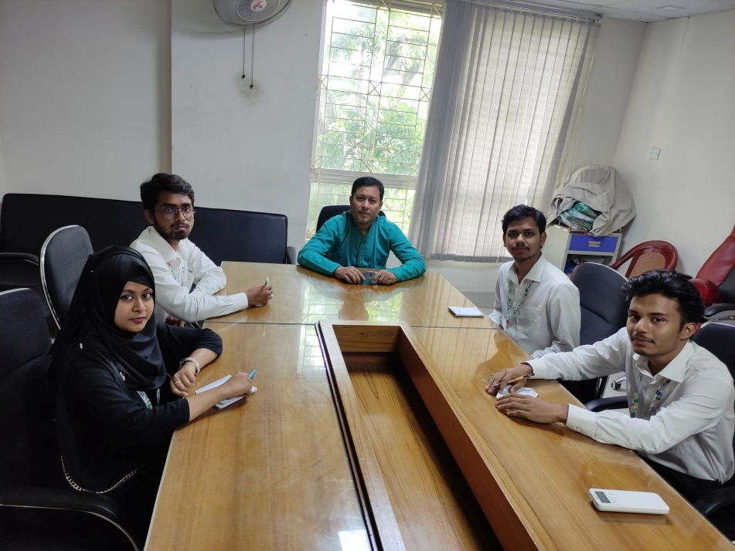

# **Informer’s Info**

**Md. Asadur Rahman**

**Director (IT)**

**Savar Specialized Hospital, Savar**

**01765425681**

# **Objectives & Impacts**

1. **Streamline Workflow:** Efficiently manage processes and automate administrative tasks such as appointment scheduling, patient registration, and billing to optimize workflow and minimize manual effort.
2. **Enhance Patient Experience:** Provide seamless access to healthcare services through features like online appointment booking, patient portals for accessing medical records, and real-time updates on treatment progress, ensuring convenience and satisfaction
3. **Improve Communication and Collaboration: Facilitate** Secure communication and information sharing among doctors, patients, pharmacy, and ambulance services to enable effective coordination and timely decision-making.
4. **Optimize Resource Management:** Effectively allocate and manage resources including doctors' schedules, medical equipment, pharmacy inventory, and ambulance availability to ensure efficient utilization and cost-effective operations.

# **Software Elicitation Technique**

**Group Interview:** We have gathered multiple stakeholders of the hospital. for the purpose to gain insights, gather requirements, and understand their perspectives collectively. They gave us proper information of their system. One of our team members led us for this requirement gathering.

**One-on-One:** We took interview one by one of the hospital management system authorities and gathered information. We are a team of 4 members and each person took interview of one person. By this we have got the detailed information of hospital management system from different perspectives.

**Interface Analysis:** We have observed their system’s interface to know how their system works. The IT director showed us their system and we analyzed their system for the purpose of gathering exact information.

**Observation:** We have observed how they use their system and how much it is helpful for the customers and admins. We have gathered information of this system also by observing the users of this system.

# **SRS Documentation**

|  |  |
| --- | --- |
| **FR 001** | Register Patient |
| **Description** | The receptionist registers patient information. |
| **Stakeholders** | Receptionist, patient, admin. |

|  |  |
| --- | --- |
| **FR 002** | Admit Patient |
| **Description** | After registration the receptionist admit the patient in a cabin. |
| **Stakeholders** | Receptionist, patient, admin. |

|  |  |
| --- | --- |
| **FR 003** | Manage Doctors |
| **Description** | After checking which doctor is free receptionist select a doctor for the admitted patient. |
| **Stakeholders** | Doctor, patient, receptionist, admin. |

|  |  |
| --- | --- |
| **FR 004** | Gather Information for Hospital Services |
| **Description** | For knowing the information of hospital service in details |
| **Stakeholders** | Admin, doctor, authority, receptionist. |

|  |  |
| --- | --- |
| **FR 005** | Gather Cabin Information |
| **Description** | For knowing that which cabin is free or filled. |
| **Stakeholders** | Admin, authority, receptionist. |

|  |  |
| --- | --- |
| **FR 006** | Create Bill of a Patient |
| **Description** | For payment receptionist create a bill of patient. |
| **Stakeholders** | Patient, receptionist. |

|  |  |
| --- | --- |
| **FR 007** | Track Financial Transaction |
| **Description** | For knowing the transaction history of any patient. |
| **Stakeholders** | Admin, authority, receptionist, owner, receptionist. |

|  |  |
| --- | --- |
| **FR 008** | Manage administrative tools |
| **Description** | For the purpose of controlling the admin panel |
| **Stakeholders** | Admin, authority. |

|  |  |
| --- | --- |
| **FR 009** | Show Print Preview |
| **Description** | Before printing anything it will show the printing page for checking. |
| **Stakeholders** | Receptionist, admin. |

|  |  |
| --- | --- |
| **FR 010** | Authenticate User |
| **Description** | For authenticate any admin user. |
| **Stakeholders** | Admin, authority. |

|  |  |
| --- | --- |
| **FR 011** | Log In to The System |
| **Description** | Admins can login in this system. |
| **Stakeholders** | Admin, authority, receptionist. |

|  |  |
| --- | --- |
| **FR 012** | Sign Up to The System |
| **Description** | For login they have to sign up in this system. |
| **Stakeholders** | Admin, authority, receptionist. |

|  |  |
| --- | --- |
| **FR 013** | Create Account |
| **Description** | For login they have to create account with their name and password. |
| **Stakeholders** | Admin, authority, receptionist. |

|  |  |
| --- | --- |
| **FR 014** | Manage Diagnostic System |
| **Description** | To manage all the lab and operational facilities. |
| **Stakeholders** | Admin, Authority, Receptionist |

|  |  |
| --- | --- |
| **FR 015** | Manage Non-Financial Transaction |
| **Description** | Non-financial transaction of hospital is managed by this. |
| **Stakeholders** | Admin, authority, receptionist. |

|  |  |
| --- | --- |
| **FR 016** | Manage Inventory |
| **Description** | For managing the hospital inventory. |
| **Stakeholders** | Admin, Authority. |

|  |  |
| --- | --- |
| **FR 017** | Investigate Test Report |
| **Description** | For investing the test report of any patient. |
| **Stakeholders** | receptionist, patient, doctor. |

|  |  |
| --- | --- |
| **FR 018** | Manage Test Report |
| **Description** | For managing the test reports of all the patients of hospital. |
| **Stakeholders** | Admin, authority, receptionist. |

|  |  |
| --- | --- |
| **FR 019** | Print Bill |
| **Description** | For printing the bill of any patient. |
| **Stakeholders** | Admin, receptionist, Patient. |

|  |  |
| --- | --- |
| **FR 020** | Print Report |
| **Description** | For printing test report of any patient. |
| **Stakeholders** | Receptionist. |

|  |  |
| --- | --- |
| **FR 021** | Manage Pharmacy System |
| **Description** | For managing the pharmacy work. |
| **Stakeholders** | Admin, authority, owner. |

|  |  |
| --- | --- |
| **FR 022** | Create Sell Report |
| **Description** | For knowing the daily sells. |
| **Stakeholders** | Admin, authority, owner, receptionist. |

|  |  |
| --- | --- |
| **FR 023** | Manage User Account |
| **Description** | For set up using account. |
| **Stakeholders** | Admin, authority, owner, receptionist. |

|  |  |
| --- | --- |
| **FR 024** | Forget Password |
| **Description** | When user forget their password can use this option for reset password. |
| **Stakeholders** | Admin, authority, owner, receptionist. |

|  |  |
| --- | --- |
| **FR 025** | Export Data |
| **Description** | For exporting data to another space. |
| **Stakeholders** | Admin, authority, owner. |

|  |  |
| --- | --- |
| **FR 026** | Show Dashboard |
| **Description** | For entering any option in this system. |
| **Stakeholders** | Admin, authority, owner, receptionist. |

|  |  |
| --- | --- |
| **FR 027** | View All Tools |
| **Description** | To view all the tools and use them easily. |
| **Stakeholders** | Admin, authority, owner, receptionist. |

|  |  |
| --- | --- |
| **FR 028** | Optime Memory |
| **Description** | To optimize the memory and do multiple tasks at once. |
| **Stakeholders** | Admin, authority, owner, receptionist. |

|  |  |
| --- | --- |
| **FR 029** | Show live time & date |
| **Description** | To view live time & date at the bottom of the dashboard. |
| **Stakeholders** | Admin, authority, owner, receptionist. |

|  |  |
| --- | --- |
| **FR 030** | Show help tutorial |
| **Description** | View tutorial for almost every part of the entire system. |
| **Stakeholders** | Admin, authority, owner, receptionist. |

|  |  |
| --- | --- |
| **FR 031** | Create patient id |
| **Description** | To find patient by their unique ID. |
| **Stakeholders** | Admin, receptionist. |

|  |  |
| --- | --- |
| **FR 032** | Manage patient details |
| **Description** | To add, remove or modify patient details. |
| **Stakeholders** | Admin, receptionist. |

|  |  |
| --- | --- |
| **FR 033** | Track patient bills |
| **Description** | To Track down patient payments and dues. |
| **Stakeholders** | Admin, authority, receptionist. |

|  |  |
| --- | --- |
| **FR 034** | Print patient details |
| **Description** | To print patient full details. It may contain their personal details and payment info. |
| **Stakeholders** | Receptionist, Patient. |

|  |  |
| --- | --- |
| **FR 035** | Create doctor id |
| **Description** | To find doctor by their unique ID. |
| **Stakeholders** | Admin, authority, receptionist, doctor. |

|  |  |
| --- | --- |
| **FR 036** | Manage doctor payment |
| **Description** | To manage doctor’s payment and dues. |
| **Stakeholders** | Admin, authority, owner. |

|  |  |
| --- | --- |
| **FR 037** | Manage doctor appointment |
| **Description** | To add, remove or edit doctor appointment. |
| **Stakeholders** | Admin, receptionist, patient. |

|  |  |
| --- | --- |
| **FR 038** | Check cabin availability |
| **Description** | Check whether the cabin is available or not. |
| **Stakeholders** | Admin, receptionist. |

|  |  |
| --- | --- |
| **FR 039** | Recruit patient to cabin |
| **Description** | Recruit patient to a cabin if it is available. |
| **Stakeholders** | Admin, patient, receptionist. |

|  |  |
| --- | --- |
| **FR 040** | Check lab availability |
| **Description** | Check whether the lab is available or not. |
| **Stakeholders** | Admin, receptionist. |

|  |  |
| --- | --- |
| **FR 041** | Create lab attendant id |
| **Description** | To find lab attendant by their unique ID. |
| **Stakeholders** | Admin, receptionist. |

|  |  |
| --- | --- |
| **FR 042** | Manage lab attendant payment |
| **Description** | To manage lab attendant payment and dues. |
| **Stakeholders** | Admin, Patient, receptionist. |

|  |  |
| --- | --- |
| **FR 043** | Assign lab attendant to lab work |
| **Description** | Assign lab attendant to attend patient and doctor. |
| **Stakeholders** | Admin, receptionist, doctor, patient. |

|  |  |
| --- | --- |
| **FR 044** | Generate lab report |
| **Description** | Make lab report automatically when system have enough data from the doctor. |
| **Stakeholders** | Admin, receptionist. |

|  |  |
| --- | --- |
| **FR 045** | Print lab report |
| **Description** | For printing lab report of any patient. |
| **Stakeholders** | Admin, receptionist. |

|  |  |
| --- | --- |
| **FR 046** | Show print preview |
| **Description** | Before printing anything it will show the lab report for checking. |
| **Stakeholders** | Admin, receptionist. |

|  |  |
| --- | --- |
| **FR 047** | Create field workers id |
| **Description** | To find field workers by their unique ID. |
| **Stakeholders** | Admin, authority, Worker, receptionist. |

|  |  |
| --- | --- |
| **FR 048** | Add target amount to field workers |
| **Description** | To give a certain amount to the field workers to achieve in a month. |
| **Stakeholders** | Admin, authority, Worker, receptionist. |

|  |  |
| --- | --- |
| **FR 049** | See details commission of field workers |
| **Description** | To view commission of field workers. It may contain their personal details and target info. |
| **Stakeholders** | Admin, authority, Worker, receptionist. |

|  |  |
| --- | --- |
| **FR 050** | Make report for commission |
| **Description** | To create a daily, weekly and monthly report on the sale commission. |
| **Stakeholders** | Admin, authority, receptionist. |

|  |  |
| --- | --- |
| **FR 051** | View medicine stock |
| **Description** | To check total medicine in the inventory. |
| **Stakeholders** | Admin, authority, owner, receptionist. |

|  |  |
| --- | --- |
| **FR 052** | Add medicine to stock |
| **Description** | Add medicine to the in the inventory when there is enough medicine in the stock. |
| **Stakeholders** | Admin, authority, receptionist. |

|  |  |
| --- | --- |
| **FR 053** | Order medicine to add in stock |
| **Description** | To order medicine directly when a couple of medicine is out of stock. |
| **Stakeholders** | Admin, authority, receptionist. |

|  |  |
| --- | --- |
| **FR 054** | View total sell |
| **Description** | To view total sell of medicine in a day, week and in a month. |
| **Stakeholders** | Admin, authority, owner, receptionist. |

|  |  |
| --- | --- |
| **FR 055** | Print sell report |
| **Description** | For printing medicine sell report of any patient. |
| **Stakeholders** | Admin, authority, owner, receptionist. |

|  |  |
| --- | --- |
| **FR 056** | Create admin id |
| **Description** | To find admin by their unique ID. |
| **Stakeholders** | Admin, authority. |

|  |  |
| --- | --- |
| **FR 057** | Manage admin profile |
| **Description** | To add, remove or modify admin details. |
| **Stakeholders** | Admin, authority, owner, receptionist. |

|  |  |
| --- | --- |
| **FR 058** | Sign in verification |
| **Description** | Send a one-time verification code or time-based one-time pin to verify users. |
| **Stakeholders** | Admin, authority, receptionist. |

|  |  |
| --- | --- |
| **FR 059** | Make monthly expenses report |
| **Description** | To create monthly expenses report for every possible way separately. |
| **Stakeholders** | Admin, authority, owner, receptionist. |

|  |  |
| --- | --- |
| **FR 060** | Manage user |
| **Description** | To add, remove or modify user details. |
| **Stakeholders** | Admin. |

|  |  |
| --- | --- |
| **FR 061** | Restrict user access |
| **Description** | To remove or limit access to certain user in case of emergency. |
| **Stakeholders** | Admin. |

|  |  |
| --- | --- |
| **FR 062** | Import data |
| **Description** | To be able to import data in different format. |
| **Stakeholders** | Admin, authority, receptionist. |

|  |  |
| --- | --- |
| **FR 063** | Search patient with id |
| **Description** | To search and view details of a patient using their unique id. |
| **Stakeholders** | Admin, authority, receptionist. |

|  |  |
| --- | --- |
| **FR 064** | Search doctor with id |
| **Description** | To search and view details of a doctor using their unique id. |
| **Stakeholders** | Admin, authority, doctor, receptionist. |

|  |  |
| --- | --- |
| **FR 065** | Search field workers with id |
| **Description** | To search and view details of a field workers using their unique id. |
| **Stakeholders** | Admin, authority, owner, receptionist. |

|  |  |
| --- | --- |
| **FR 066** | Create pharmacist id |
| **Description** | To find pharmacist by their unique ID. |
| **Stakeholders** | Admin, authority, receptionist. |

|  |  |
| --- | --- |
| **FR 067** | Manage pharmacist |
| **Description** | To add, remove or modify pharmacist details. |
| **Stakeholders** | Admin, authority, receptionist. |

|  |  |
| --- | --- |
| **FR 068** | Manage pharmacist commission |
| **Description** | To modify, add or remove commission on medicine sell of a pharmacist. |
| **Stakeholders** | Admin, authority, receptionist. |

|  |  |
| --- | --- |
| **FR 069** | Create commission report |
| **Description** | To make a daily, weekly and monthly report of sell commission. |
| **Stakeholders** | Admin, authority, receptionist. |

|  |  |
| --- | --- |
| **FR 070** | Manage online payment system |
| **Description** | To view, add, modify, remove, restrict online payment methods. |
| **Stakeholders** | Admin, authority, receptionist. |

|  |  |
| --- | --- |
| **FR 071** | Manage refund |
| **Description** | To refund according to the policy of the hospital. |
| **Stakeholders** | Admin, authority, receptionist, Patient. |

|  |  |
| --- | --- |
| **FR 072** | Create campaign |
| **Description** | For creating campaign on special occasion and provide more health care services. |
| **Stakeholders** | Admin, authority, receptionist. |

|  |  |
| --- | --- |
| **FR 073** | Add campaign details |
| **Description** | To add campaign details, policy and deadline while creating a new campaign. |
| **Stakeholders** | Admin, authority, receptionist, receptionist. |

|  |  |
| --- | --- |
| **FR 074** | Create campaign report |
| **Description** | To create campaign report at the end of the campaign. |
| **Stakeholders** | Admin, authority, receptionist. |

|  |  |
| --- | --- |
| **FR 075** | Print campaign report |
| **Description** | For printing campaign success and learning. |
| **Stakeholders** | Admin, authority, receptionist, receptionist. |

|  |  |
| --- | --- |
| **FR 076** | Manage doctor availability |
| **Description** | To modify doctors’ availability and give appointment. |
| **Stakeholders** | Admin, authority, doctor, receptionist. |

|  |  |
| --- | --- |
| **FR 077** | Create ambulance id |
| **Description** | To find ambulance by their unique ID. |
| **Stakeholders** | Admin, authority, receptionist. |

|  |  |
| --- | --- |
| **FR 078** | Manage ambulance details |
| **Description** | To view, add, modify, remove ambulance details. |
| **Stakeholders** | Admin, authority, receptionist. |

|  |  |
| --- | --- |
| **FR 079** | Manage ambulance availability |
| **Description** | To modify ambulance availability and give appointment. |
| **Stakeholders** | Admin, authority, receptionist. |

|  |  |
| --- | --- |
| **FR 080** | Create ambulance report |
| **Description** | For creating daily, weekly and monthly report on ambulance performance. |
| **Stakeholders** | Admin, authority, receptionist. |

|  |  |
| --- | --- |
| **FR 081** | Track ambulance rides |
| **Description** | For tracking ambulances’ current ride info and route path. |
| **Stakeholders** | Admin, authority, receptionist. |

|  |  |
| --- | --- |
| **FR 082** | Book ambulance |
| **Description** | To book the ambulance for a ride. |
| **Stakeholders** | Admin, authority, patient, receptionist. |

|  |  |
| --- | --- |
| **FR 083** | Cancel ambulance |
| **Description** | To cancel ambulance ride. |
| **Stakeholders** | Admin, authority, patient, receptionist. |

|  |  |
| --- | --- |
| **FR 084** | Cancel doctor appointment |
| **Description** | To cancel doctor appointment and make the doctor available. |
| **Stakeholders** | Admin, authority, patient, receptionist. |

|  |  |
| --- | --- |
| **FR 085** | Cancel lab test |
| **Description** | To cancel lab appointment and make the lab available. |
| **Stakeholders** | Admin, authority, patient, receptionist. |

|  |  |
| --- | --- |
| **FR 086** | Manage discount for hospital employees |
| **Description** | To create, add and modify special discount for hospital employees. |
| **Stakeholders** | Admin, authority, employee, receptionist. |

|  |  |
| --- | --- |
| **FR 087** | Check operation room availability |
| **Description** | To check whether the operation room is available or not. |
| **Stakeholders** | Admin, authority, receptionist. |

|  |  |
| --- | --- |
| **FR 088** | Track operation expenses |
| **Description** | For tracking down daily, weekly and monthly expenses on overall operation. |
| **Stakeholders** | Admin, authority, receptionist. |

|  |  |
| --- | --- |
| **FR 089** | View security cameras |
| **Description** | To view what security cameras are capturing. |
| **Stakeholders** | Admin, authority, receptionist. |

|  |  |
| --- | --- |
| **FR 090** | Troubleshoot problems |
| **Description** | To remove some problems without bothering the team. |
| **Stakeholders** | Admin, authority, receptionist. |

|  |  |
| --- | --- |
| **FR 091** | Reboot system |
| **Description** | For rebooting the system to remove some unwanted problems. |
| **Stakeholders** | Admin, authority, receptionist. |

|  |  |
| --- | --- |
| **FR 092** | Show tutorials |
| **Description** | Show tutorials on almost every section when needed. |
| **Stakeholders** | Admin, authority, receptionist. |

|  |  |
| --- | --- |
| **FR 093** | Check lab room availability |
| **Description** | To check whether the lab room is available or not. |
| **Stakeholders** | Admin, authority, receptionist. |

|  |  |
| --- | --- |
| **FR 094** | Report problems |
| **Description** | To make reports of bugs and system crush. |
| **Stakeholders** | Admin, authority, receptionist. |

|  |  |
| --- | --- |
| **FR 095** | Appointment confirmation |
| **Description** | To confirm doctor appointment by text message and email. |
| **Stakeholders** | Admin, authority, receptionist. |

|  |  |
| --- | --- |
| **FR 096** | Payment confirmation |
| **Description** | To confirm payment confirmation by text message and email. |
| **Stakeholders** | Admin, authority, patient, receptionist. |

|  |  |
| --- | --- |
| **FR 097** | Send lab report online automatically |
| **Description** | Send lab report to the patient via email if the dues are clear. |
| **Stakeholders** | Admin, authority, receptionist. |

|  |  |
| --- | --- |
| **FR 098** | Manage loyalty discount |
| **Description** | To view, add, remove loyalty discount when a patient takes services for the second time. |
| **Stakeholders** | Admin, authority, receptionist. |

|  |  |
| --- | --- |
| **FR 099** | Show report ready message |
| **Description** | To show popup message when a report is ready to view or print. |
| **Stakeholders** | Admin, authority, receptionist. |

|  |  |
| --- | --- |
| **FR 100** | Manage dashboard |
| **Description** | To view all the summarized information in the dashboard and use the tools. |
| **Stakeholders** | Admin, authority, receptionist. |

|  |  |
| --- | --- |
| **FR 101** | Configure online payment system |
| **Description** | To configure new payment method to the system. |
| **Stakeholders** | Admin, authority, receptionist. |

|  |  |
| --- | --- |
| **FR 102** | Create daily checkout report |
| **Description** | To show how many patient is being discharged and its’ related details. |
| **Stakeholders** | Admin, authority, receptionist. |

|  |  |
| --- | --- |
| **FR 103** | Add discharge info |
| **Description** | To add information about patient discharge and calculate total due. |
| **Stakeholders** | Admin, authority, receptionist. |

|  |  |
| --- | --- |
| **FR 104** | Cancel discharge |
| **Description** | To cancel discharge in case of emergency. |
| **Stakeholders** | Admin, authority, receptionist. |

|  |  |
| --- | --- |
| **FR 105** | Add new security camera |
| **Description** | For adding new security camera to manage and view. |
| **Stakeholders** | Admin, authority, receptionist. |

|  |  |
| --- | --- |
| **FR 106** | Configure security camera |
| **Description** | To change brightness, camera angle and its’ related information of the security camera. |
| **Stakeholders** | Admin, authority, receptionist. |

|  |  |
| --- | --- |
| **FR 107** | Separate dashboard |
| **Description** | To manage tools and view dashboard separately according to users position. |
| **Stakeholders** | Admin, authority, receptionist. |

|  |  |
| --- | --- |
| **FR 108** | Separate access point |
| **Description** | To access separate dashboard using their unique passcode. |
| **Stakeholders** | Admin, authority, receptionist. |

|  |  |
| --- | --- |
| **FR 109** | Track Payment of a Patient |
| **Description** | To track dues and payments of a patient. |
| **Stakeholders** | Admin, authority, receptionist. |

|  |  |
| --- | --- |
| **FR 110** | Check Availability of a Doctor |
| **Description** | To check if the doctor is available or not. |
| **Stakeholders** | Admin, authority, doctor, receptionist. |

|  |  |
| --- | --- |
| **FR 111** | Appoint Doctors |
| **Description** | To appoint doctor for a patient. |
| **Stakeholders** | Admin, authority, doctor, receptionist. |

|  |  |
| --- | --- |
| **FR 112** | View Payment of Patient |
| **Description** | View payment information of a patient. |
| **Stakeholders** | Admin, authority, receptionist. |

|  |  |
| --- | --- |
| **FR 113** | Check Availability of Lab Room |
| **Description** | To check if lab room is available or not. |
| **Stakeholders** | Admin, authority, receptionist. |

|  |  |
| --- | --- |
| **FR 114** | Track Medicine Stock |
| **Description** | Track all the medicine, view medicine quantity and expiration date. |
| **Stakeholders** | Admin, authority, receptionist. |

|  |  |
| --- | --- |
| **FR 115** | Manage users |
| **Description** | To manage who can access to the system and make changes of data. |
| **Stakeholders** | Admin, authority, receptionist. |

|  |  |
| --- | --- |
| **FR 116** | Search Patient using ID |
| **Description** | To search the patient using their unique ID. |
| **Stakeholders** | Admin, authority, receptionist. |

|  |  |
| --- | --- |
| **FR 117** | Manage financial Transaction |
| **Description** | To view, track and edit financial transaction. |
| **Stakeholders** | Admin, authority, receptionist. |

# **Use Case Design**

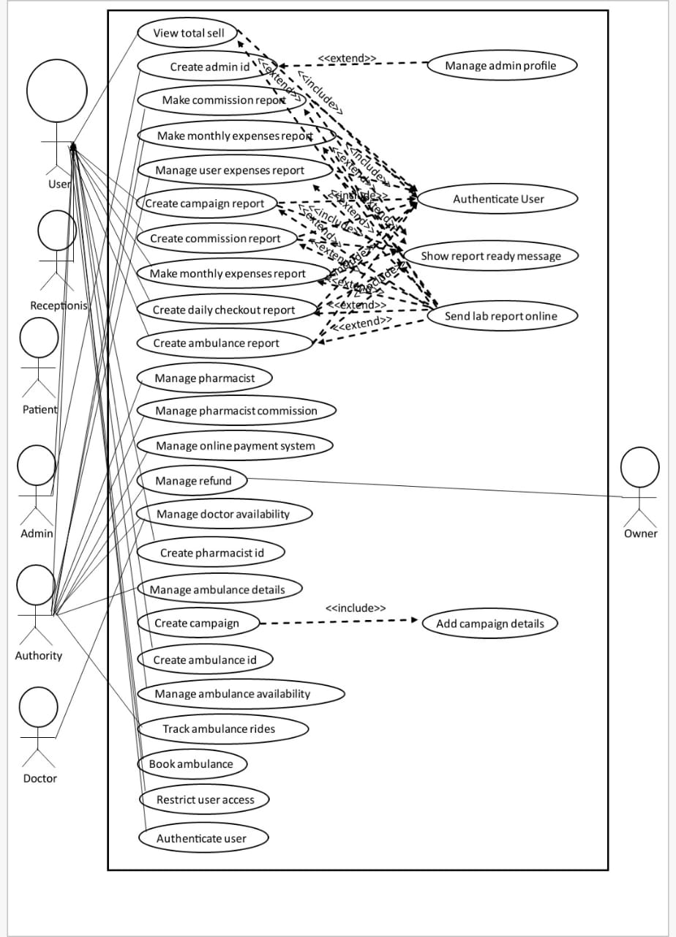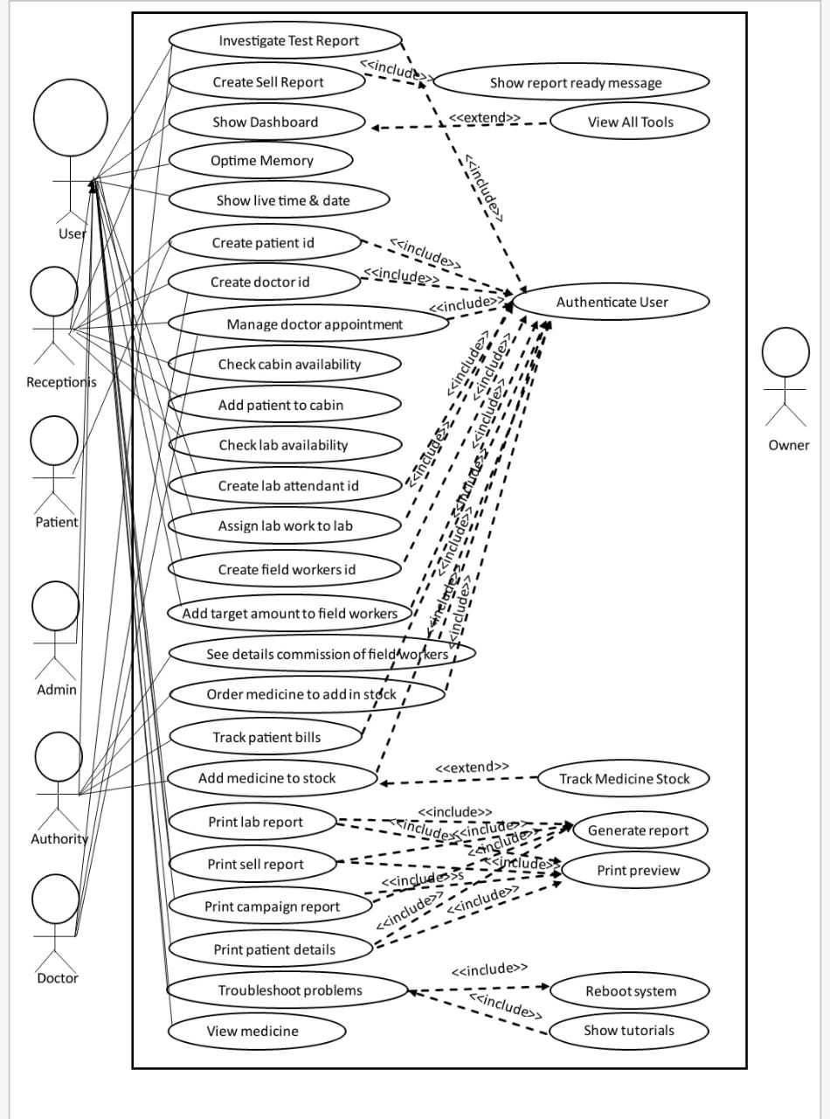

# **Use Case Description**

## View Total Sell

|  |  |
| --- | --- |
| **Use Case:** | View total sell. |
| **Goal:** | View the total sales generated by the hospital within a specified time period. |
| **Precondition:** | The user attempting to view the total sales must have appropriate authentication credentials and privileges to access the Hospital Management System. |
| **Success End Condition:** | Message: Total sales for the specified time period: $X |
| **Failed End Condition:** | Message: Invalid credentials. Please enter valid authentication details to access the system. |
| **Primary Actors:** | Receptionist, authority. |
| **Secondary Actors** | Admin, owner. |
| **Trigger:** | Requests to view the total sales. |
| **Description / Main Success Scenario:** | |  |  | | --- | --- | | **1.** | The administrator logs into the Hospital Management System. | | **2.** | The system authenticates the administrator's credentials and grants access. | | **3.** | The administrator navigates to the financial module or dashboard within the system. | | **4.** | The system presents a menu of financial-related options. | | **5.** | The administrator selects the "View Total Sales" option. | | | **6.** | The system prompts the administrator to enter the desired time period for which the sales are to be viewed (e.g., day, week, month, year). | | | **7.** | The administrator provides the time period or selects it from a calendar widget. | | | **8.** | The system retrieves the sales data from the database based on the specified time period. | | | **9.** | The system calculates the total sales amount based on the retrieved data. | | **10.** | The system displays the total sales amount to the administrator on the screen. | | **11.** | The administrator can choose to print or export the sales report if needed. | |
| **Alternative Flows:** | |  |  | | --- | --- | | **1.a** | If the entered password wrong. | |  | **1.a.1** Message: “Password is incorrect.” | | **2.a** | If the system could not connect to the server. | |  | **2.a.1** Message:” Server could not found.” | | **4.a** | If page not found | |  | **4.a.1** Message: “404! Page not found.” | | **5.a** | The Administrator enters an invalid or non-existent time period (e.g., a future date, a date range that exceeds available data). | |  | **5.a.1** Message: “Invalid time period. Please enter a valid time period.” | | **5.b** | The system determines that there are no sales records available within the specified time period. | |  | **5.b.1** Message: “No sales data available for the specified time period.” | |
| **Quality Requirements:** | The system should provide accurate calculations of total sales amount with high precision and ensure quick response times for retrieving and displaying the total sales information. |

## Admit Patient

|  |  |
| --- | --- |
| **Use Case:** | Admit patient |
| **Goal:** | Admit patient to suitable cabin based on their needs. |
| **Precondition:** | Patient must be registered with a unique identification number before admitting. |
| **Success End Condition:** | Message: “Admission successful” |
| **Failed End Condition:** | Message: “Admission failed: please try again” |
| **Primary Actors:** | Patient, Receptionist |
| **Secondary Actors** | Admin, owner. |
| **Trigger:** | Receptionist will request to admit patient. |
| **Description / Main Success Scenario:** | |  |  | | --- | --- | | **1.** | Receptionist will request to admit patient. | | **2.** | The system will provide the list of cabins available for the patient. | | **3.** | Receptionist will select a suitable cabin for the patient. | | **4.** | Receptionist will press the admit button. | | **5.** | The system will check if all the required information is given correctly. | | | **6.** | The system will store the information and provide message: “Patient admission successful” | | |
| **Alternative Flows:** | |  |  | | --- | --- | | **1.a** | If the system could not connect to the server. | |  | **1.a.1** Message: “Server could not found.” | | **2.a** | If page not found | |  | **1.a.1** Message: ”404! Page not found” | | **4.a** | If the system could not connect to the server. | |  | **4.a.1** Message: “Server could not found.” | | **5.a** | If mandatory information has not been filled in. | |  | **5.a.1** Message: “Please fill in all the required information” | | **5.b** | If the information provided is not correct. | |  | **5.b.1** Message: “Information is not correct: please fill in properly” | | **6.a** | If the information could not store. | |  | **6.a.1** Message: “Information could not store: please try again later.” | |
| **Quality Requirements:** | The system should accurately capture and record patient information during the admission process, including personal details, medical history, and insurance information. |

## Manage Doctor

|  |  |
| --- | --- |
| **Use Case:** | Manage doctors |
| **Goal:** | Manage doctors for appointments |
| **Precondition:** | Both the doctor and patient must be registered in the system with their id numbers. |
| **Success End Condition:** | Message: “Doctor appointment successful” |
| **Failed End Condition:** | Message: “Appointment failed: please try again” |
| **Primary Actors:** | Patient, Receptionist, Doctor |
| **Secondary Actors** | Admin, owner. |
| **Trigger:** | Receptionist will request to appoint a patient to a particular doctor. |
| **Description / Main Success Scenario:** | |  |  | | --- | --- | | **1.** | Receptionist will request for the appointment of a patient. | | **2.** | The system will provide the list of doctors based on the need of the patients. | | **3.** | Receptionist will select a suitable doctor for the patient. | | **4.** | The System will provide the date and time the doctor is available on. | | **5.** | The receptionist will select a date and time based the confirmation of the patient. | | | **6.** | The receptionist will press the ‘confirm appointment’ button. | | | **7.** | The system will store the information and provide message: “Doctor appointment successful” | | |
| **Alternative Flows:** | |  |  | | --- | --- | | **1.a** | If the system could not connect to the server. | |  | **1.a.1** Message: “Server could not found.” | | **2.a** | If page not found | |  | **1.a.1** Message: ”404! Page not found” | | **3.a** | If the doctor’s information could not found | |  | **3.a.1** Message: “Information is unavailable” | | **4.a** | If the system could not connect to the server. | |  | **4.a.1** Message: “Server could not found.” | | **4.b** | If page not found | |  | **5.a.1** Message: “404! Page not found” | | **7.a** | If the information could not store. | |  | **6.a.1** Message: “Information could not store: please try again later.” | |
| **Quality Requirements:** | The system should accurately provide the date and time of the doctors availability so as to make a hassle free appointment. |

## Investigate Test Report

|  |  |
| --- | --- |
| **Use Case:** | Investigate test report |
| **Goal:** | Investigate the test reports of a patient: if the report is ready or not |
| **Precondition:** | Patient must be registered in the system with his/her unique ID number. |
| **Success End Condition:** | Message: “The report is ready” |
| **Failed End Condition:** | Message: “The report is not ready yet” |
| **Primary Actors:** | Patient, Receptionist, Doctor |
| **Secondary Actors** | Admin, owner. |
| **Trigger:** | Patient will ask a receptionist to investigate the test report. The receptionist will request to see the report of the patient. |
| **Description / Main Success Scenario:** | |  |  | | --- | --- | | **1.** | Receptionist will request to see the report of a patient. | | **2.** | The system will ask to enter the id number of the patient. | | **3.** | Receptionist will enter the ID number and press the submit button. | | **4.** | The System will check the ID number with the test reports that have been submitted | | **5.** | The System will provide the information of the test reports. | | |
| **Alternative Flows:** | |  |  | | --- | --- | | **1.a** | If the system could not connect to the server. | |  | **1.a.1** Message: “Server could not found.” | | **1.b** | If page not found | |  | **1.b.1** Message: ”404! Page not found” | | **4.a** | If the id number is incorrect. | |  | **4.a.1** Message: “Please enter a valid ID number” | | **4.b** | If the system could not find any report assigned to the patient ID | |  | **4.b.1** Message: “The patient has not been assigned to any test” | | **5.a** | If page not found | |  | **5.a.1** Message: “404! Page not found” | | **5.b** | If the information could not found | |  | **5.b.1** Message: “Please try again later ” | |
| **Quality Requirements:** | The system must have all the records of the test and should assure that all the test reports and their results are thoroughly reviewed. It should leave no room for missing and overlooked information. |

# **User Profile of ADMIN**

|  |  |  |
| --- | --- | --- |
| User Class | Note of Characteristic | Requirement Implied |
| Type of User | Admin | Interface |
| Age Range | 35-50 | Interface |
| Frequency of Use | Serval Times a Day | Performance, Portability, Operation, Safety, Security & Quality |
| Mandatory | Yes | N/A |
| Computer Experience | Must | Performance, Quality, Operation |
| Education | BSC (hons) | Verification |
| Goals | Maintaining system | Performance, Portability, Operation, Safety, Security & Quality |
| Language Skills | Bangla, English | Resource, Operation & Quality |
| Number of Users | 1 | Operation, Safety & Security |
| Training | Yes | Operation & Safety |
| Other System Used | Maybe | Operation, Performance |
| Ways of Working | To give support | Performance, Portability, Operation, Safety, Security & Quality |

**Requirement prioritization (Moscow)**

|  |  |  |  |
| --- | --- | --- | --- |
| **Must** | **Should** | **Could** | **Would** |
| Register Patient | Manage Doctors | Gather Cabin Information | Gather Information for Hospital Services |
| Admit Patient | Track Financial Transaction | Show Print Preview | Export Data |
| Create Bill of a Patient | Manage administrative tools | Show Dashboard | Optime Memory |
| Authenticate User | Investigate Test Report | View All Tools | Show help tutorial |
| Log In to The System | Manage Test Report | Show live time & date | Restrict user access |
| Sign Up to The System | Manage Pharmacy System | Create lab attendant id | Import data |
| Create Account | Manage User Account | Assign lab work to lab attend | Add campaign details |
| Manage Non-Financial Transaction | Manage patient details | Add target amount to field workers | Create campaign report |
| Manage Diagnostic System | Track patient bills | Make report for commission | Print campaign report |
| Manage Inventory | Print patient details | Manage user | Show tutorials |
| Print Bill | Manage doctor appointment | Create commission report | Send lab report online automatically |
| Print Report | Check cabin availability | Create campaign | Manage loyalty discount |
| Create Sell Report | Add patient to cabin recruit | Create ambulance report | Show report ready message |
| Forget Password | Check lab availability | Track ambulance rides | Manage dashboard |
| Create patient id | Generate lab report | Book ambulance | Separate dashboard |
| Create doctor id | Print lab report | Cancel ambulance | Separate access point |
| Manage doctor payment | See details commission of field workers | Track operation expenses |  |
| Manage lab attendant payment | Order medicine to add in stock | Troubleshoot problems |  |
| Create field workers id | Print sell report | Report problems |  |
| View medicine stock | Manage admin profile | Add discharge info |  |
| Add medicine to stock | Make monthly expenses report | Cancel discharge |  |
| View total sell | Search patient with id | Add new security camera |  |
| **Must** | **Should** | **Could** | **Would** |
| Create admin id | Search doctor with id | Configure security camera |  |
| Sign in verification | Search field workers with id |  |  |
| Create pharmacist id | Manage pharmacist |  |  |
| Manage online payment system | Manage pharmacist commission |  |  |
| Create ambulance id | Manage refund |  |  |
| Check operation room availability | Manage doctor availability |  |  |
| Payment confirmation | Manage ambulance details |  |  |
| Configure online payment system | Manage ambulance availability |  |  |
| Track Medicine Stock | Cancel doctor appointment |  |  |
| Search Patient using id | Cancel lab test |  |  |
| Manage financial Transaction | Manage discount for hospital employees |  |  |
|  | View security cameras |  |  |
|  | Reboot system |  |  |
|  | Check lab room availability |  |  |
|  | Appointment confirmation |  |  |
|  | Create daily checkout report |  |  |
|  | Track Payment of a Patient |  |  |
|  | Check Availability of a Doctor |  |  |
|  | Appoint Doctors |  |  |
|  | View Payment of Patient |  |  |
|  | Check Availability of Lab Room |  |  |